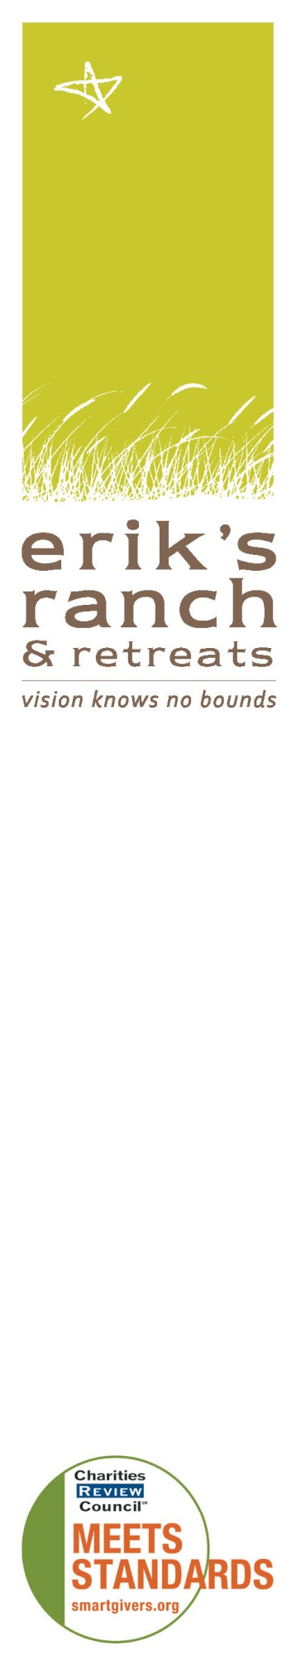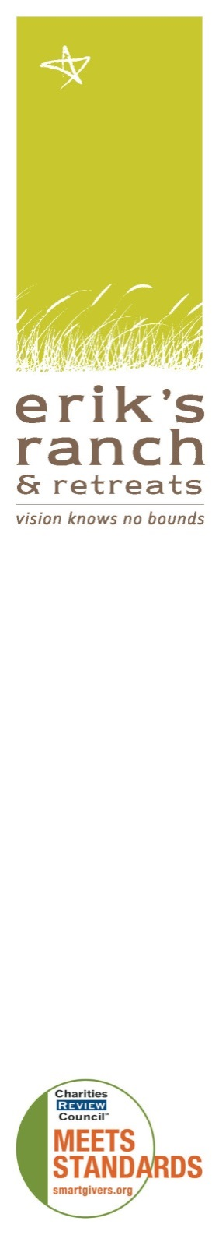C:\Users\Lisa\AppData\Local\Temp\Image_0**Call for Artists on the autism spectrum**

**Diamonds in the Rough: Art Sale and Exhibit**

On **October 11**, an art sale hosted by Griffin Gallery, the distinguished fine art gallery and renowned Bill Mack studio, will benefit Erik’s Ranch & Retreats, a premier residence and work place for adults with autism and artists on the autism spectrum.

This exhibit and sale of art will showcase artworks from individuals on the autism spectrum and emerging and established local, national and international artists. We encourage artists with autism to donate an original art masterpiece to help raise awareness and funds for our programs. In turn, we will share 50 percent of the proceeds from your submission. This art sale is an opportunity for artists on the autism spectrum to secure an outlet for their art as well as receive compensation. Your information will be included in our art program to offer you further exposure and recognition.

REQUIREMENTS

* Artists must be age 16 or older and offer artwork in one of three sizes, 5 x 7”, 8 x 10” or 16 x 20”.
* Erik’s Ranch & Retreats reserves the right to price art for this event.
* Submit a high-resolution pdf or jpg of each submission no later than July 30 to [art@eriksranch.org](mailto:art@eriksranch.org). Include: artist name and contact information, medium, size and title of the artwork.
* Art will be juried for inclusion; artist will be notified of acceptance by Aug 15.
* All accepted artwork is due August 30. All framed art and canvasses must be wired on the back.
* For artists who live far from Minnesota, your high-resolution jpg or pdf will be displayed on a screen for viewing and purchase. (See Submission guidelines at [www.eriksranch.org](http://www.eriksranch.org) for more information.)
* All work must be labeled on the back, with artist name, artwork title, artist contact information, website (optional). In addition, please complete an artist submission form (found on our website, [www.eriksranch.org](http://www.eriksranch.org)) for each piece of art or pdf/jpg submitted.
* All artists must complete and sign an artist agreement, which we will send upon acceptance of your art, or your artwork will not be exhibited in our juried sale.

For more information, including questions about how to submit work for consideration, email [art@eriksranch.org](mailto:artinfo@eriksranch.org), or visit our website, [www.eriksranch.org](http://www.eriksranch.org). We look forward to hearing from you. Please note that this is a fundraiser for Erik’s Ranch & Retreats and donations are tax-deductible to the full extent provided by law.

**Erik’s Ranch & Retreats**

Erik’s Ranch & Retreats provides safe and unequaled living, working, social and recreational environments for young adults with autism, using its guiding principles of lifelong learning, individual community building and bidirectional integration through voluntourism. We’re committed to giving these individuals a rewarding life on their own terms, experiencing dignity, compassion and the joy of continuing possibility. [www.eriksranch.org](http://www.eriksranch.org) - 612-222-9665

**Griffin Gallery**

Griffin Gallery, the Twin Cities’ distinguished destination for fine art, is the premier source for traditional, contemporary and collectible fine art from emerging and established local, national and international artists. Griffin Gallery caters to residential and corporate clients, as well as professionals in the design community, offering art consulting, custom framing and installation services. [www.griffingalleryfineart.com](http://www.griffingalleryfineart.com)